Renesas Flash Programmer User Instruction

1. Please install the Renesas Flash Programmer Installer V3.0:

Double click the Renesas_Flash_Programmer_Package_V30000.exe file, and follow the instruction to install it properly.

1. Double click the Renesas Flash Programmer V3.00 shortcut to open it.

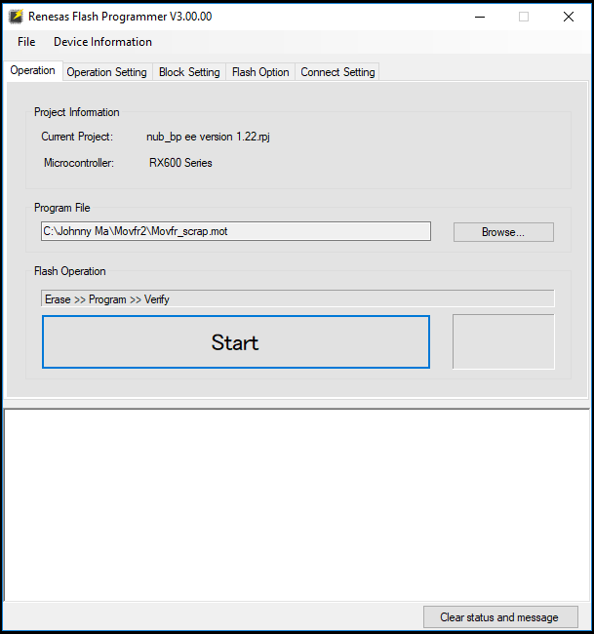

1. Click the File tab, and select the object Create a new project.

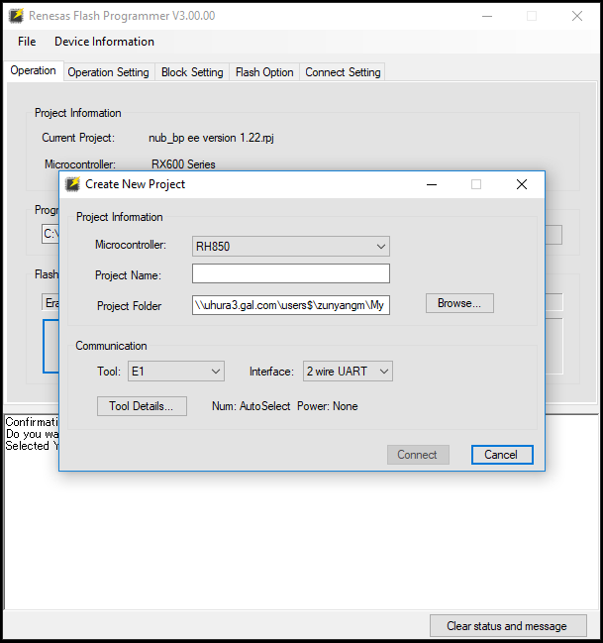

1. Please choose the right micro In the Microcontroller section, fill out the Project Name and locate the Project Folder.

For the Communication section, please keep the setting as the picture show below.

For MOVFR II board,

Microcontroller MUST BE RX62x

Project Name is Movfr II New Firmware Update v1.22

Project Folder is C:\Johnny Ma\Movfr2

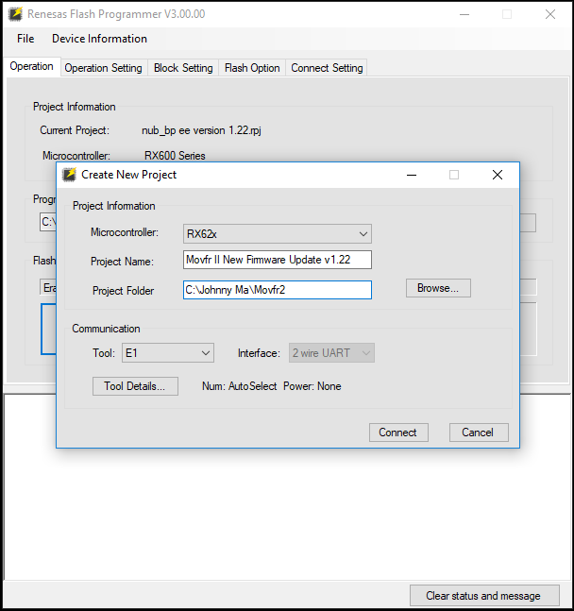

1. In this step, the MOVFR II board is required to be powered.

After that, please connect the Renesas Flash Programmer to the MOVFR II board, and click the Connect tab on the Renesas Flash Programmer V3.00.

1. While the connection is built successfully, it requires the Main Clock.

For MOVFR II board,

Main Clock MUST BE 9.21 MHz.

Then click OK to go to next.

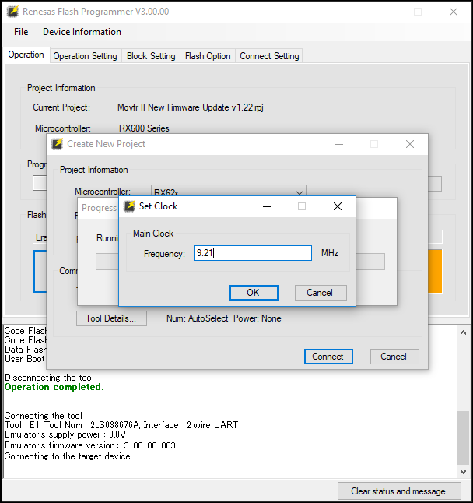

1. Everything looks good here, and now please provide the Program File for it.

For MOVFR II board,

Program File MUST BE Movfr_scrap.mot

Then you are set, and click the Start tab to program the MOVFR II board.

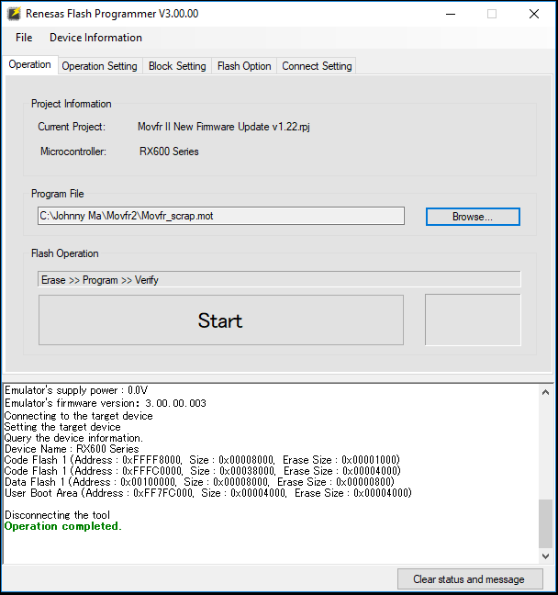

1. The MOVFR II board is programmed successfully while it shows as below:

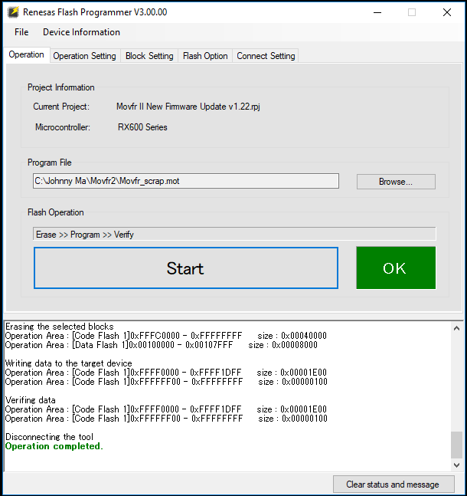

1. Now it is the last step to save the current project by click on the File tab and select the object Save the current project.
2. Open an exist project:

Double click the Renesas Flash Programmer V3.00 shortcut to open it.

Then click on the File to select the object Open a project.

Please choose the project’s rpj file and tab Open.

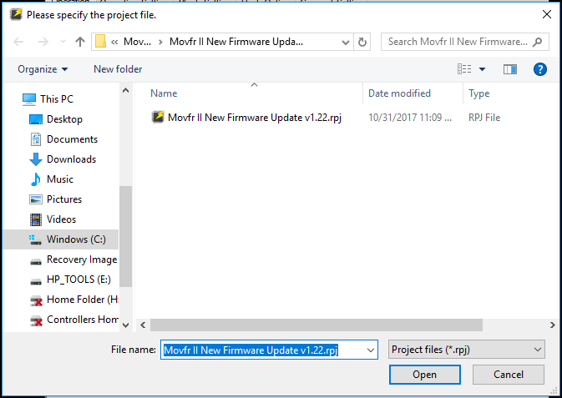

1. Please don’t forget to power and connect the programmer to the MOVFR II board.

Now it is ready to click the Start to program the boards.

Contact Information:

**Zunyang(Johnny) Ma**

Electrical Engineer

Product Development / Electrical R&D.

Email: [Zun.Ma@GAL.com](mailto:Zun.Ma@GAL.com)

TEL (718) 292-9000 ext. 203